

Bajaj Finserv Health Dev Challenge (Qualifier 1)

# Note: This is a full stack challenge – involves both backend and frontend parts. Completion of both challenges are required for all candidates.

*Candidates are free to use online resources including, but not use any ai tools*

*Note: Refer to the end for submission instructions*

# Backend

## Objective

Build and deploy a REST API with one endpoint that accepts requests with both GET and POST methods.

**POST** method endpoint takes in the request (JSON) and returns the following:

1. Status
2. User ID

### College Email ID

1. **College Roll Number**
2. Array for numbers
3. Array for alphabets

**GET** method endpoint doesn’t take any user input, it just returns an *operation_code*

- ***Please refer to Annexure (A) for request/response samples***

# Hosting

Any provider of your choice, if you don’t have one already, please use [Heroku](https://www.heroku.com/) / [Netlify](https://www.netlify.com/) / [Vercel](https://vercel.com/) / Firebase or any other provider that provides REST API deployment.

# Logic – (2 Parts)

### Route: /bfhl | Method: POST

* 1. Example: <https://testbfhl.herokuapp.com/bfhl> [POST Method]
  2. Response should always contain your user_id (fullname_dob) in the following format
     1. "user_id": {full_name_ddmmyyyy}

E.g.: "user_id”: "john_doe_17091999"

* 1. “is_success” should be returned in the response to mark the status of operation. It can

be true / false

### Route: /bfhl | Method: GET

* 1. Example: <https://testbfhl.herokuapp.com/bfhl> [GET Method]
  2. ***Doesn’t take any input from the user.*** *The endpoint will be hit with a GET request, that’s*

*it.*

* 1. Expected HTTP Status Code: 200
  2. Expected Response Body (hardcoded) (JSON):

{

“operation_code”:1

}

*Note: Be sure to follow other best practices including exception handling, input validation and others.*

# Annexure (A) - (ONLY FOR POST REQUEST)

### Example A

*Note: If an alphabet is present in the input, it will always be a single character, never a word. And “highest_alphabet” refers to the alphabet from the input array which occurs last in the A-Z series (case insensitive).*

### Request

{

"data": [“M”,”1”,”334”,”4”,”B”]

}

### Response

{

"is_success": true,

"user_id": "john_doe_17091999", “email” : “[john@xyz.com](mailto:john@xyz.com)”, “roll_number”:”ABCD123”, "numbers": [“1”,”334”,”4”],

"alphabets": [“M”,”B”], “highest_alphabet”:[“M”]

}

### Example B

**Request**

{

"data": [“2”,”4”,”5”,”92”]

}

### Response

{

"is_success": true,

"user_id": "john_doe_17091999", “email” : “[john@xyz.com”,](mailto:john@xyz.com) “roll_number”:”ABCD123”,

"numbers": [“2”,”4”,”5”,”92”],

"alphabets": [],

“highest_alphabet”:[]

}

### Example C

**Request**

{

"data": ["A",”C”,”z”]

}

### Response

{

"is_success": true,

"user_id": "john_doe_17091999", “email” : “[john@xyz.com”,](mailto:john@xyz.com) “roll_number”:”ABCD123”,

"numbers": [], "alphabets": ["A",”C”,”z”], “highest_alphabet”:[“z”]

}

# Frontend

## Objective

Develop and deploy a frontend application that uses the backend you’ve developed to process the input and get response, then render it on frontend. (Preferably React based – including frameworks like Next.js, but that’s optional).

## Logic

1. The application should have a text input that accepts JSONs that are from the previous section’s (backend’s) request. Example - { "data": ["A",”C”,”z”] }
2. The frontend application should call the REST API that you’ve created to process the data in request

and return the response as per the logic mentioned in backend challenge.

## Details

Create a user interface with the following features:

* 1. Text input field and submit button:
     + Accepts only valid JSON input
     + Validates JSON format on submission, show error in case of invalid input
     + Calls the REST API that you’ve created, with payload from the text input
     + Gets the response and then uses the following logic to render it
  2. Multi-Select Dropdown:
     + Appears after valid JSON submission
     + Contains the following options:
       1. Alphabets
       2. Numbers
       3. Highest alphabet
  3. Response shown on frontend will be basis options selected from dropdown. E.g. if user selects Alphabets & Numbers then response should render data associated only with alphabets & numbers
  4. Also, the website title should be your roll number

Eg: In the following image, “Google” is the title of the first tab.



# Sample Output:

In case, user selects Numbers & Highest Alphabet from Multi Filter, response will look as following:

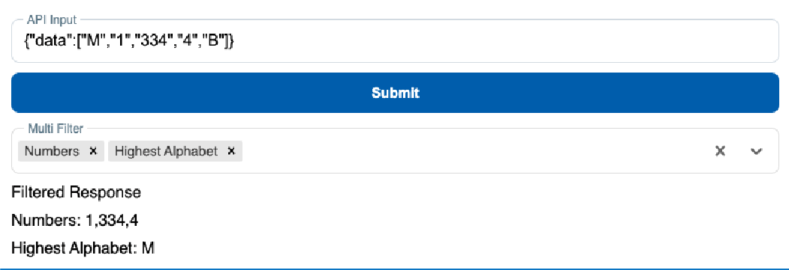

In case, user selects only Numbers from Multi Filter, response will look as following:

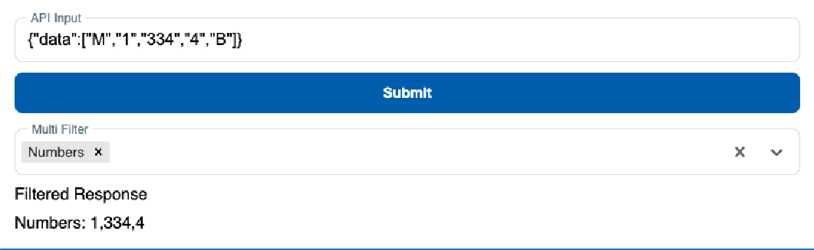

# Submission

1. Host your backend & frontend applications
2. Share your backend API endpoint (ending in /bfhl) and frontend application URL in the following form:

Form Link: <https://www.surveymonkey.com/r/Qualifier1CU>

1. Fastest valid submissions will be considered
2. Any attempt to duplicate submissions or assist others will lead to disqualification of both candidates

**\*DO NOT FORWARD THIS DOCUMENT\***